How to theorise education:
Wits Doctoral Weekend Workshop 2014

Exercise 1

Lets analyse policy statement extracts on the four phases South African curriculum reform has gone through in the last 20 years using six variables and two states. It will help to use summary codes. By solid line we mean strong separation between things and insistence on one way of doing things; by open line we mean integration between things and openness to a number of possible options.

Relationship between everyday/specialised: solid or open line
e|s — or – –

Relationship between specialisations: solid or open line
sp|sp — or – –

Relationship between sub-disciplines: solid or open line
(sub|sub) — or – –

Selection of lesson content: solid or open line
sel — or – –

Sequencing of lesson content: solid or open line
seq — or – –

Pacing of lesson: solid or open line
p — or – –

In a box after the extract you will find some codes and a summary of the phrase it relates to. Don’t expect all codes to be used for every extract.

Apartheid Education:

The old South African system has not served the country well and is out of step with world trends. It catered to passive learners, was driven by examinations, often entailed learning in parrot‑fashion, and was characterized by a syllabus which encouraged minimal cross fertilization in that it was content‑based and broken down into convenient compartments or subjects. It rigidly adhered to textbooks and worksheets and was thus completely centred on the teacher, with the result that the learner saw the syllabus as rigid and non‑negotiable.

Code | Apart-heid education  code | Reason
e|s
— or – –
sp|sp
— or – –
sub|sub
— or – –
sel
— or – –
seq
— or – –
p
— or – –

Curriculum 2005: With the onset of democracy in South Africa there was a strong desire to do education differently from old, apartheid ways. A radical new education reform process was inaugurated that symbolically broke away from Apartheid education.

The learning programmes are seen as guides, educators are encouraged to be innovative and creative in designing effective courses for the learners entrusted to their care. The learners are responsible for their own learning and progress, constantly motivated by feedback and positive comment concerning the worth of their efforts. Since assessment is continuous, time‑frames are flexible and learners learn at their own pace. And comment, constructive criticism, and assistance from the wider community is actively encouraged … Transformational OBE involves the integration of concepts in a cross‑curricula approach which embraces not only the structure of the curriculum, but also the methods by which instruction is delivered and meaningful assessments made.

Code | C2005 Learner centred outcome based education | Reason
e|s
— or – –
sp|sp
— or – –
Sub|sub
— or – –
sel
— or – –
seq
— or – –
p
— or – –

Revised National Curriculum Statement [RNCS]:
There were major issues with the implementation of C2005, forcing policy reform to solidify the variables whilst still sticking to the moral and emotional appeal of learner centered, outcomes based education. Look out for passages that catch how the RNCS both tried to keep to the opening of education variables we saw with C2005 but at the same time solidified the lines to give more structure and guidance to both the curriculum and how it is taught

Indeed, this curriculum [RNCS] is aimed at and focused on those teachers and learners who need it most. Many have argued that the first version of the Department’s outcomes-based curriculum has worked in better-resourced schools but not in schools with large classes, for example. This curriculum is designed in such a way that it will work in the most impoverished schools and be useful to those teachers with the least resources. If it does not fulfill this requirement, we will have failed in our task. This curriculum does not make unrealistic assumptions about the conditions in our schools. It goes beyond spelling out what the learning outcomes should be and provides the necessary detail required to show how the outcomes can be realised without restricting teachers to a narrow syllabus. A scourge of our education system now and in the past has been the practice of learning by heart, often without any real understanding of what was being learned.
Outcomes-based education provides the methodology and path out of that trap. This curriculum accordingly encourages active learning, creativity and innovation even as it assists teachers in focusing their attention on key areas of knowledge, skill and values that ought to be covered while respecting the rights of learners.

Code | RNCS | Reason
e|s
— or – –
sp|sp
— or – –
sub|sub
— or – –
sel
— or – –
seq
— or – –
p
— or – –

It’s at this point that, as a theorist of education, you might feel that two states [open/solid] are inadequate. It is clear that the RNCS is moving from a state of open lines to more solid lines. Maybe we need four states, not two?
1: Solid
2: Shifting from solid to open
3: Open
4: Shifting from open to solid
Four states would certainly help us to catch the reform dynamic more clearly. Unlike computers that can work simply with a binary on\off code, education processes are more complex and dynamic. As useful as a simple binary code between solid and open states are for getting education theorising off the ground, we have to learn how to work with more states as we become adept.

Curriculum Assesment Policy Statements [CAPS]– a speech by Angie Motshekga on the death of OBE:

The question on everyone’s lips is why we do not, as Mamphela Ramphele always wants us to do, declare the death certificate of outcomes-based education, OBE? I must say that we have, to all intents and purposes, done so. So if anybody asks us if we are going to continue with OBE, we say that there is no longer OBE. We have completely done away with it. [Applause.] …. It is instructive to remember that the introduction of both Curriculum 2005 and the National Curriculum Statement were highly contested. These involved professional, business and religious constituencies. We should be steadfast and not let them determine what is good for education now… Because there was a very strange anomaly in our system in which the importance of textbooks in curriculum delivery was no longer appreciated. The department has noted teachers’ concerns that the development of learning materials is best placed in the hands of experts, because it is only people who are experts in their fields of study that are best placed to develop textbooks and learning materials. In this review teachers said that the development of learning materials is not the core business of teachers. It also erodes their teaching time. Therefore, textbooks are going to be used as an effective tool to ensure consistency, coverage, appropriate pacing and better quality in terms of instruction and content.

Code |  | Reason
e|s
— or – –
sp|sp
— or – –
sub|sub
— or – –
sel
— or – –
seq
— or – –
p
— or – –

Summarise the developments in South African education policy reform:

Education reform in South Africa | Apartheid education | Transformational OBE/C2005 | RNCS | CAPS
State

— or — —

Exercise 2:

Here are 6 regulative principles that could be in conflict or compromise: Take the three regulative principles not covered in the plenary session and put them into conflict and alliance with each other.

6 regulative principles | Common Humanity | Common Dignity | Common Worth
Traditional | We are all born and we all die. In the time between we need to learn our heritage and then take responsibility for transferring our traditions from one generation to the next | Hierarchy from adult to child and from master to apprentice where all can aspire to mastery although only a few will reach the top. Those who listen and obey their elders will develop habits and character that enable a reaching of higher levels | Tradition establishes continuity in change and benefits everyone whether they obey or not
Marketability | We are all selfish individuals seeking to improve ourselves | Competition for scarce resources results in winners and losers but everyone has equality of opportunity. Generic skills are vital to adapt to the market as it changes and those who invest in flexibility of skills and networking will have more chance of success | Free markets and generic skills result in improved efficiency, distribution of resources, innovation, and flexibility that benefits everyone because it creates a dynamic and progressive society
Creativity | We are all creative and passionate | Need to take risks and detours, deny glory and fame, sacrifice quick pleasures to reach heights of creativity that result in new paths rather than going down the same track | A creative world is better for everyone, including those who do not reach their creative potential, because it introduces vibrancy, invention, and beauty that was not there initially
Care | We all want to love and be loved | Through the development of receptive attention and empathy we reach a state of caring that is open and nurturing rather than mere obligation | A caring world is better for everyone as it results in a world that is open, empathic, and nurturing.
Citizen | We all need to participate in society as we belong to the collective. We are all a part of society | We need to shift from a particular will that focuses on selfish or local ends to a general will that takes everyone’s interests into account when making a decision. Sacrifice and renunciation of personal and particular interests will result in a civic man who is free from personal desire | A civic world is better for everyone as it enables a society in which everyone’s interests are considered and worked with, rather than a selfish world of boastfulness, jealousy and corruption
Specialise | We are all dependent on each others skills | Hierarchy from common sense local knowledge to specialised knowledge where long years of study are invested in to increase specialisation. There are many different types of specialisation and this allows all sorts access | A specialised world deals with more problems in more effective ways. It gives more time to everybody to do what they do best and rely on other specialists to do what they do best, resulting in a better world for everybody

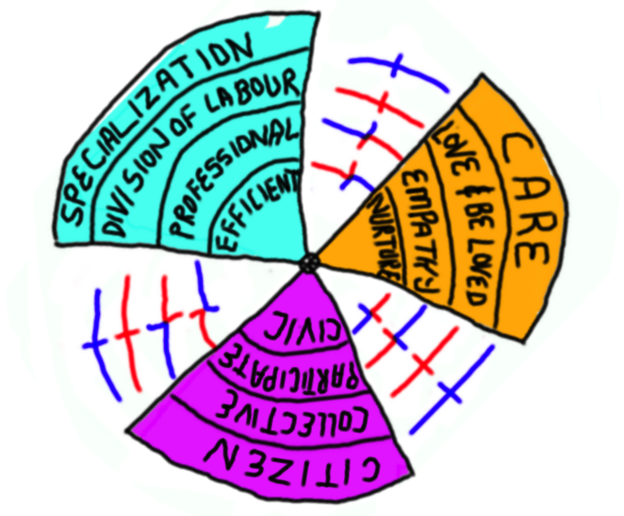

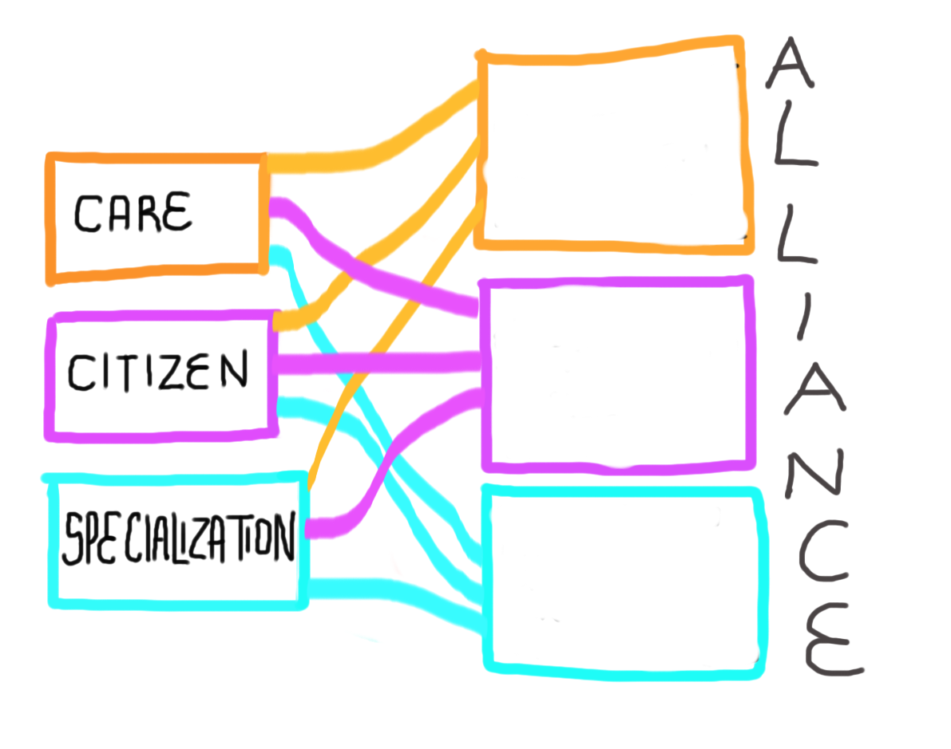

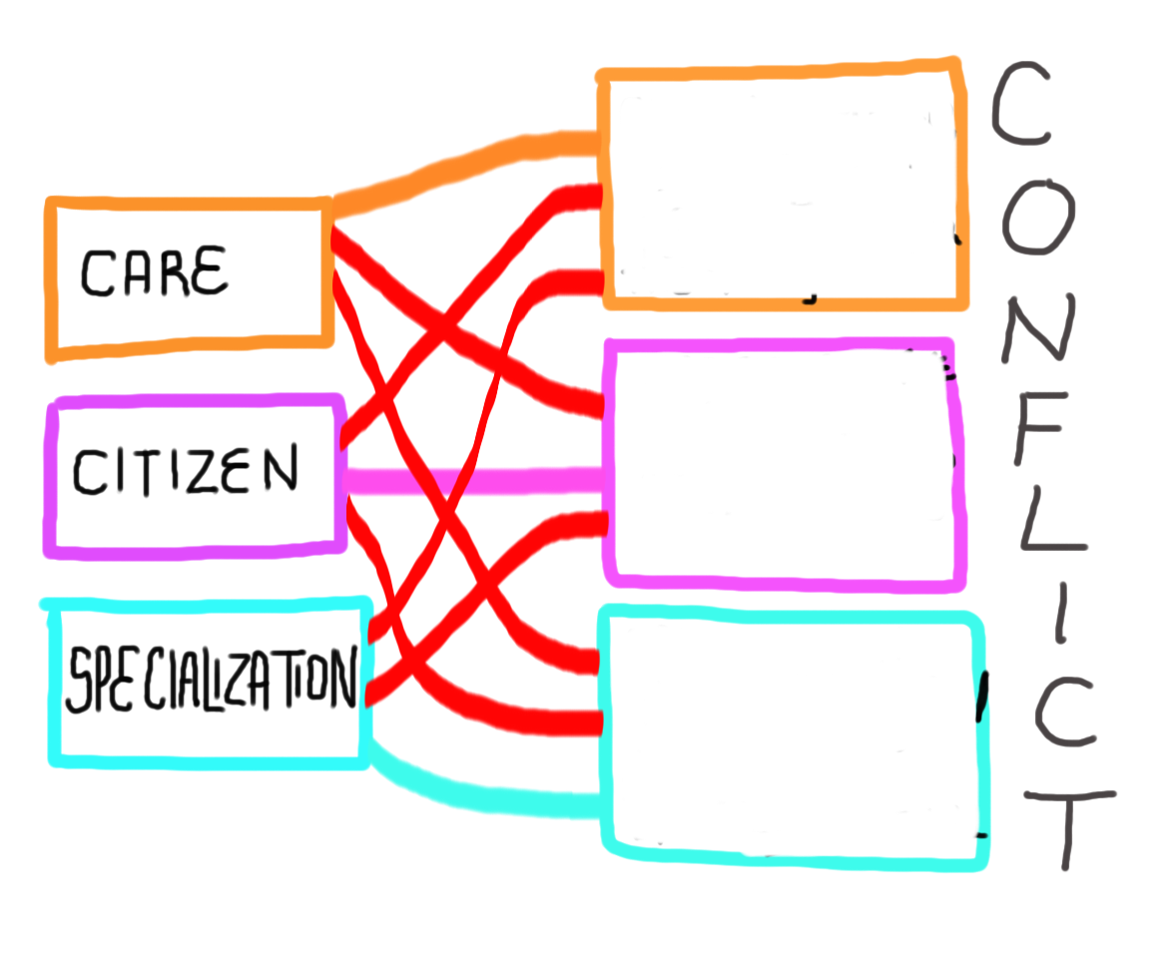

Exercise 3a:

Detailed example of arguing for a regulative principle in Education: Nell Noddings and an ethics of Care: Identify Common Humanity (we are all the same) Common dignity (we all have strategies to reach the heights of care) Common Worth (care is good for all of us)

For Noddings (1984), a common humanity is found in relationships. Its an ontologically basic feature of human existence, and at the ethical heart of a relationship lies care. It is our original condition to be thrown defenseless into the world and to be cared for by someone else. It’s a deeply fulfilling relation that results in joy. It’s the experience of joy that continues to drive us towards care, it gives us the energy to care, and because we have joy as a driving force, its gives all of us the ability to enter into and sustain relationships of care. We all have a natural inclination to care, it is what makes us human. But that does not mean that caring is not hard work, that it asks for certain kinds of sacrifices, and that there are levels within care. We might love those close to us easily, but what of those who you are not close to, but still feel that you should care for them, that you ought to care for them, that it is your duty to care. Noddings makes a distinction between natural caring and ethical caring, with ethical caring taking extra emotional labour – something teachers are very familiar with. There are specific practices that enable better forms of caring. One has to be engrossed by the other, pay attention to their needs, think about them and what is best for them, feel for their situation. Often this is hard to do, and results in guilt, which must be continuously fought against. Relationships might be ontologically basic, and caring ethically basic, but that does not mean everyone cares in the same way or even cares at all. It takes sacrifice and hard work to do it properly. And even when done properly, a caring attitude has to be received, acknowledged, and worked with by the cared for, otherwise the relation is incomplete.
If children are educated in a way that builds within them an ethic of care, then society as a whole will benefit as social policies move towards stronger caring ideals (Noddings 2002a, p223, quoted by R. Bergman 2004, Journal of moral education).

Common Humanity | Draw  Arrow to sentence | Justify:
Common Dignity | Draw  Arrow to sentence | Justify:
Common Worth | Draw  Arrow to sentence | Justify
Exercise 3b

Noddings does not stop there, she discusses specific instructional strategies that help develop an ethic of caring. I think you can guess whether each one is going to be open or solid. I will provide the quote, you do the coding:

- Relationship between_______________________________________:

‘Themes of care connect our students and our subjects to great existential questions. What is the meaning of life? Are there gods? How should I live?’(p2)

All teachers should be prepared to respond to the needs of students who are suffering from the death of friends, conflicts between groups of students, pressure to use drugs or to engage in sex, and other troubles so rampant in the lives of today’s children. (p4)

- Relationship between ________________________________________:

‘Themes of care help us to connect the standard subjects. The use of literature in mathematics classes, of history in science classes, and of art and music in all classes can give students a feeling of the wholeness of their education.’ (p2)

- Relationship ________________________________________________:

Biology students may learn something of the of the anatomy and physiology of mammals but nothing at all about the care of living animals.

- S_________________:

‘Curriculum can be selected with caring in mind…Within each large domain of care, many topics are suitable for thematic units: in the domain of ‘caring for self’, for example, we might consider life stages, spiritual growth, and what it means to develop an admirable character.’ (P2)

- S__________________:

For example, as we discuss in math classes the attempts of great mathematicians to prove the existence of God… students will hear names, ideas, and words that are not part of the standard curriculum. Although such incidental learning cannot replace the systemic and sequential learning required by those who plan careers in mathematically oriented fields, it can be powerful in expanding students’ cultural horizons (p2)

- P___________ :

A policy of keeping students and teachers together…for several years supports caring in two essential ways: it provides time for the development of caring relations, and it makes teaching themes of care more feasible… It should be legitimate for them to spend time developing relations of trust (p5).
Note this is also an open relationship between teacher and student

 | Ev/sp | Sp/sp | Inside sp |  | selection | sequence | pace
Code
Reason

Exercise 4:

Shift in ratios of teachers:
In less developed systems most teachers are poorly educated and trained (time 1); in more developed systems most teachers are very well educated and trained. Try and draw the shift in ratios from poorly educated and trained teachers to well educated and trained teachers.

